# PeopleSafe - Adding a Controlled Substance (CS) State ID for Kentucky

Reminders

Input Member ID Information

Related Documents

**Description:** There is a growing desire with state, local, and federal governments to get a better understanding of how we as an industry are dispensing controlled substances and how consumers are receiving them. This process will ensure we comply with applicable laws when dispensing C2-C5 drugs, as they are put in place.

|  |
| --- |
| Reminders |

When dispensing C2-C5 drugs, laws may require a member to provide their Social Security number, for example.

**Note:** Kentucky is the only state with this requirement.

* Kentucky requires the members Social Security number.

Participant Services will reach out to members who need to provide additional identification to fill a Controlled Substance prescription. The member will be instructed to contact Participant Services with that information. However, if the member calls into Care, we can input their ID information into the Patient Profile on PeopleSafe.

**Note:** There is no need to contact Participant Services once the member’s information is input into the system. The system will update and the order will be released.

If a member needs to provide State ID information, it will be notated in the **Prescription Comment** section of the **Order Status** screen.

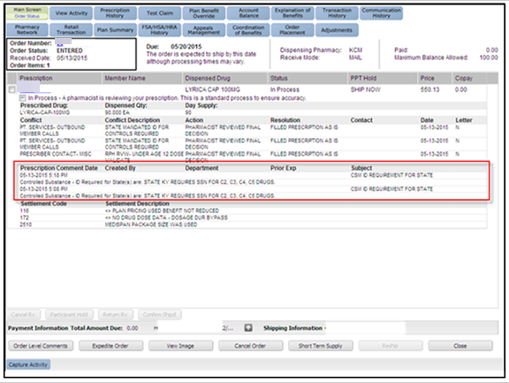

**Figure A: Order Status Screen**

Top of the Document

|  |
| --- |
| Input Member ID Information |

Follow the process below to input member ID information into the **Patient Profile** in PeopleSafe:

|  |  |
| --- | --- |
| **Step** | **Action** |
| **1** | **Select** the appropriate member in PeopleSafe. |
| **2** | From the **Main Screen**, click the **Maintain Patient Profile** button. |
| **3** | Click the **State ID CS** button.    **Result:** The **Maintain Special ID** pop-up box displays.    **Maintain Special ID Pop-Up Box with ID**  **Note:** If the member has ID information on file, part of the ID number will be visible in the pop-up box. |
| **4** | Select the **ID Type** and **State** from the drop-down menus. |
| **5** | Type the ID number in the **ID Type** field; type the ID’s expiration date in the **Expiration Date** field.   * The ID number provided must be for the person who the prescription is for except in the case of a minor or disabled dependent.   **Note:** The member will need to provide a Social Security Number. Otherwise, the order **will not** process.  No expiration date is required when entering a Social Security Number. |
| **6** | Click **ADD**. |

Top of the Document

|  |
| --- |
| Related Documents |

[Customer Care Abbreviations, Definitions and Terms (017428)](https://thesource.cvshealth.com/nuxeo/thesource/#!/view?docid=c1f1028b-e42c-4b4f-a4cf-cc0b42c91606)

**Parent Document:** [CALL 0049 Customer Care Internal and External Call Handling](https://policy.corp.cvscaremark.com/pnp/faces/DocRenderer?documentId=CALL-0049)

Top of the Document

Not to Be Reproduced or Disclosed to Others without Prior Written Approval

**ELECTRONIC DATA = OFFICIAL VERSION / PAPER COPY = INFORMATIONAL ONLY**